Business Requirements Document
On Your Side: Nationwide’s Automobile Policy Rate Management System -GSRM

Purpose | The purpose of this BRD is to define the system needs and expectations of the customer, and to ensure that the system components are compatible and comply with the enterprise-wide standards and direction defined by the Agency. This is a living document; requirements can be refined, added upon, clarified, or even removed.
Ownership | The project development team is responsible for preparing the BRD document. Prior to proceeding, the document must include approvals from the key Stakeholders.
Applicability | A BRD is a required deliverable on all system development projects.

Author: | SDLC Team
Version: | 1.0
Status | Rough Copy
Date: | 2017-12-12

Document Revision History
Date | Version | Description | Author
11/19/2017 | 0.1 | Updated Document to include Sections where they are not applicable to this assignment. | T. Arenburg
12/12/2017 | 1.0 | Finished and ready for evaluation

Submitters OF FINAL DOCUMENT
Role | Name | Signature | Date
 | Richard Rennehan |  | 12/12/2017
 | Hsiang-Wei Chen |  | 12/12/2017
 | Maddie Robinson |  | 12/12/2017
 | Ryan Burgoyne |  | 12/12/2017

Reviewers OF FINAL DOCUMENT
Role |  | Review Completed | Date

Approvers OF FINAL DOCUMENT
Role | Name | Signature | Date
 | Tanyia Arenburg

By accepting this Business Requirements Document you are agreeing to the details contained in this document. No changes will be made to this agreement without additional acceptance from each party signed above.

Table of Contents
1 Introduction 7
1.1 Project Background 8
1.2 Intent 9
1.3 Scope 10
1.4 Stakeholders 10
1.5 Definitions, Acronyms and Abbreviations 11
1.6 Assumptions 12
1.7 Dependencies 12
1.8 Constraints 12
1.9 Critical Success Factors 13
2 Business Requirements 14
2.1 As-Is State 14
2.1.1 Current Assessment of the System Environment 14
2.1.2 As-Is Diagrams 15
2.1.2.1 System Context Diagram 15
2.1.2.2 Business Process Model 15
2.2 To-Be OR FUTURE State 16
2.2.1 To-Be Diagrams 16
2.2.1.1 System Context Diagram 16
2.2.1.2 Business Process Model 16
3 Functional Requirements 17
3.1 Functional Area 1-N – [Identify area] 17
3.2 Business Rules 17
3.3 Regulatory Requirements 18
3.4 Data Reporting Requirements 18
3.5 Interface/Integration Requirements 18
Database Mapping 19
3.6 Data Dictionary 19
3.7 ER Diagrams (Logical Model) 20
4 Detailed Functional Requirements 20
4.1 Sub-system 20
4.2 Component Type 20
4.3 Component 1 20
5 Non-Functional Requirements 21
5.1 Technical Requirements 21
5.1.1 Applicable Current Standards 21
5.1.2 Accessibility 22
5.1.3 Encryption 23
5.1.4 Hosting 23
5.1.5 Environment 23
5.1.6 Business Continuity 23
5.1.6.1 Disaster Recovery 24
5.1.7 Security Analysis 24
5.1.7.1 Application Security 25
5.1.7.1.1 Security Requirements 25
5.1.7.1.2 Application Access and Decision Making Authorization 25
5.1.7.1.3 ISO Security Model (Data Classification) 25
5.1.8 Data Integrity 25
5.1.9 Design Constraints 26
5.1.10 Non-User Interfaces 26
5.1.10.1 Hardware Interfaces 26
5.1.10.2 Software Interfaces 27
5.1.10.3 Communications Interfaces 27
5.1.11 Legal, Copyright and Other Notices 28
5.1.12 Purchased Components and Licensing Requirements 28
5.2 Operational Requirements 29
5.2.1 System Performance 29
5.2.1.1 Availability 30
5.2.1.2 System Capacity and Scalability Requirements 30
5.2.1.3 Usability Requirements 30
5.2.2 Flexibility Requirements 31
5.2.3 Robustness Requirements 31
5.2.4 Audit and Controls 31
5.2.5 Software Quality Assurance (SQA) 31
5.2.6 System Administration 32
5.2.7 Backup and Recovery 32
5.2.8 Archiving and Retention Requirements 32
5.3 Transitional Requirements 33
5.3.1 Data Conversion 33
5.3.2 Training Requirements 33
5.3.2.1 Roles of Customers/Consumers of the System 33
5.3.3 Support Requirements 34
5.3.4 Documentation 34
5.3.5 Help 35
5.3.6 Deployment 35
5.3.7 Release Validation 35

Introduction

The following project contains information on the implementation of Nationwide’s new project. It includes all the requirements that must be considered to ensure satisfaction of customers and legal agents. It is divided into 5 parts:

- Introduction to the Project
- Business Requirements
- Functional Requirements
- Detailed Functional Requirements (Not applicable to project)
- Non-Functional Requirements

Project Background

Nationwide is currently experiencing a data crisis. An overload of redundant data is making data processing and reports near impossible. After acquiring Allied, the mismatch between each company's data requires two separate reports to be made before a company-wide report can even begin. The ability for Nationwide to do quick, accurate data reports is necessary to stay in business.

As a solution, Nationwide is planning a project called The Goal State Rate Management Project (GRSM). This project will improve the flow of business through the inclusion of a central data warehouse along with new processes to reduce data redundancy.

The following diagram displays our company background
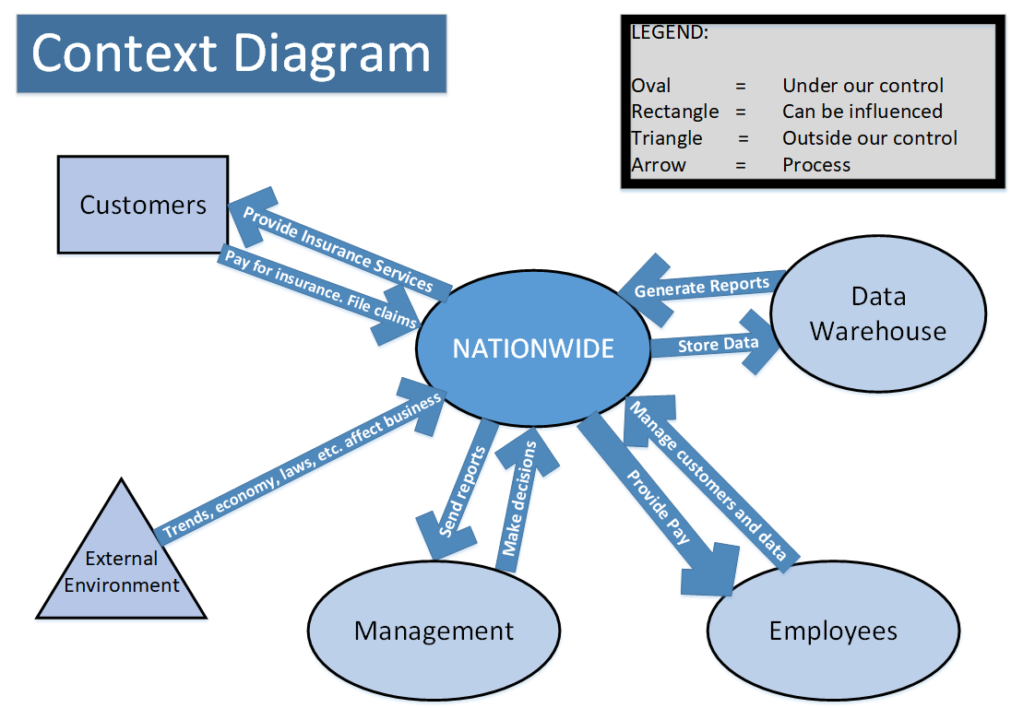

Intent

The intent of the solution is to reduce processing time from months to what should be seconds.
Additional benefits include the ability to provide users with a unified way to do reporting, a large increase in data quality, and the ability to re-rate products near instantaneously. All of these benefits will ensure we exceed the needs and expectations of the customer.

Nationwide desires to be the best data, reporting, and pricing tool in the property and casualty industry. A solution is much needed not only to satisfy the customer, but to satisfy state insurance regulators as well. With state insurance regulators demanding policy-repricing statistics every 3 months, Nationwide cannot keep up the pace at the current rate of operations.

Scope

The scope of the project covers the entire company. This includes all business units, systems, and locations. Every employee will be affected. Eventually, the old system will be entirely replaced by the new one.

The main functional requirement is to allow reports and data processes to be run accurately within seconds, no matter the circumstances. Certain circumstances that may prevent this include too many concurrent users, errors within the data, and system outages for example.

An analysis phase will kick off the project. As part of the project, the requirements of the customer, of legal agents, and the business itself must be considered. The analysis phase should be completed by February 2018. The design phase will follow. In the design phase, important decisions regarding the system will be made. Any new discoveries in this phase will be considered and possibly implemented. The design phase should be complete by May 2018. Following, the new system will be implemented piece by piece until it replaces the old system. Nationwide expects the new system to be fully implemented by December 1, 2018.

Stakeholders

The following is a list of contributors to the business along with their contributions:

- Sales team carries out sales
- Customers generate profits
- Data infrastructure stores data, creates insurance policies and generates reports
- IT team manages data and infrastructure
- Management receives reports and makes decisions for the company

The follow is a list of contributors who have a direct impact on the project

- Teradata has provided Nationwide a data storage solution that meets the needs for the GRSM project
- Allied shares its data with Nationwide

Definitions, Acronyms and Abbreviations

Term | Definition
GSRM | Goal State Rate Management
PCR | Price Cycle Readiness
POD | Portable On-Time Decisions
STDB | Short Term Database
LTDB | Long Term Database
RTO | Recovery Time Objective
RPO | Recovery Point Objective
VPN | Virtual Private Network
DBMS | Database Management Software

Assumptions

# | Assumptions
1 | 80% of customers do the majority of business online
2 | Customers want fast reliable services

Dependencies

# | Dependencies
1 | Nationwide depends on customers, who desire quality insurance at a good price
2 | Allied depends on Nationwide
3 | Data Structure depends on IT Team
4 | Data depends on the infrastructure
5 | Policy depends on data
6 | Management depends on data reports generated
7 | Customers depend on Nationwide and its services for insurance

Constraints

# | Constraints
1 | Budget may reduce scope of the project
2 | Deadlines to get reports out
3 | Availability and low-willingness of employees may slow down work
4 | Competitors may snatch customers, reducing Nationwide's source of revenue
5 | Government brings laws and other restrictions that may restrict freedom
6 | Current infrastructure slows business to a crawl
7 | Internal regulation
8 | Far external factors, such as new laws, natural disasters, etc.

Critical Success Factors

Critical Success Factors
Team collaboration and a universal understanding across the team
Senior management support
Well-designed plan and time frame
Properly planned budget
Gather requirements and meet them
Qualified personnel
Right equipment and technology to bring the project to life

Business Requirements

As-Is State

Current Assessment of the System Environment

The process in concern is the ability to generate reports and perform analysis quickly and accurately. It lies in the data infrastructure and the IT team environment.

Currently, it is near impossible to generate reports and perform analysis. This is due to data redundancy, inconsistent policies, and data inconsistencies across the board. Pulling out the correct data compares to finding a needle in a haystack. Additional issues emerged when Nationwide acquired Allied. To generate a company-wide report, two separate reports have to be generated first before work can even begin. As a result, all work involving data is very time-consuming. Because of all the time consumed, Nationwide cannot handle customer demands as well as the requirements from state insurance regulators. State insurance regulators demand re-pricing reports each quarter, and Nationwide cannot keep up. Eventually, even our most loyal customers will turn their backs.

The system can be improved. A solution is to integrate data and data processing services from both Nationwide and Allied’s systems. This will eliminate data redundancy as well as the unnecessary complexity of the system.

As-Is Diagrams

System Context Diagram

Not included. Only one diagram is needed for as-is, according to the assignment

Business Process Model

The following diagram displays the current company-wide report process:
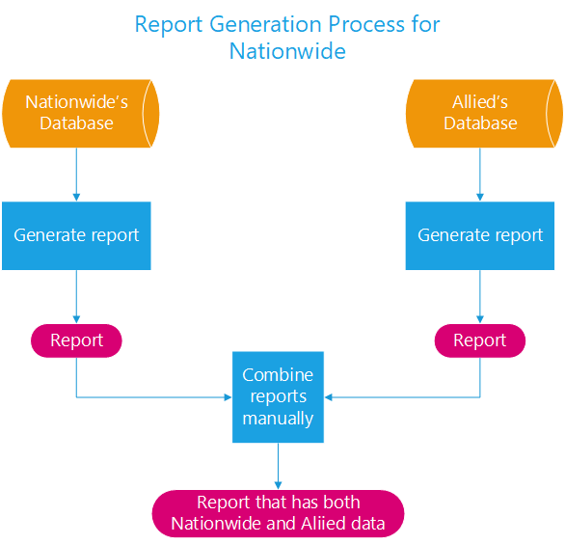

To-Be OR FUTURE State

To-Be Diagrams

System Context Diagram

The following diagram demonstrates how each system and process will interact in our GSRM solution:
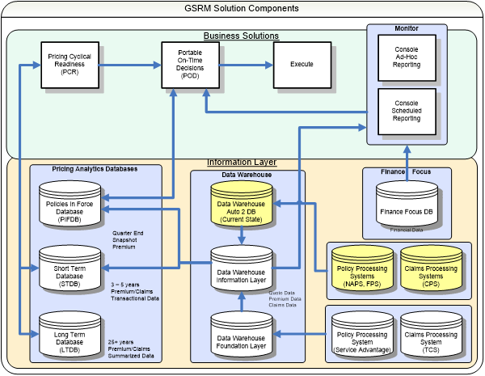
(Retrieved from On your Side: Nationwide's Automobile Policy rate Management System-GSRM, 12/11/17)

Business Process Model

Not included. Only one future state diagram is required according to the assignment.

Functional Requirements

Functional Area 1-N – [Identify area]

# | Requirements | Priority  M – Must  S – Should  C – Could  W – Won’t | Additional Information
1 | Quick and accurate data reports within seconds | M | Ensure good decisions are made and provide quality reports to regulators
2 | Integrate Nationwide and Allied’s systems | M
3 | Improve efficiency across the board | M
4 | The database should generate competitive policies for customers | S | Diverse policies, options, etc.
5 | Provide accurate policy-repricing statistics for state insurance regulators each quarter | M
6 | Manage and update data to ensure efficiency and accuracy | M

Business Rules

Business Rule and Validation Requirements | Rule Type  (Data Validation, Business Constraint, Computation)
Customer should receive a quote within 5 seconds online | Computation
Data must be updated to match real-time. | Computation
Load processing should take within 30 seconds to complete | Computation
All employees work for one department. One department hosts many employees | Business Constraint
Department reports are generated every week. Company-wide reports are generated monthly | Business Constraint
If the system receives invalid data, it prompts for re-entry before it processes it | Data Validation
Data from Nationwide and Allied will be sent to a central data warehouse | Business Constraint

Regulatory Requirements

Not applicable to this assignment.

Data Reporting Requirements

# | Requirements | Priority  M – Must  S – Should  C – Could  W – Won’t | Additional Information
1 | All date formats are in YYYY-MM-DD | M
2 | Policy re-pricing statistics generated and sent each quarter to state insurance regulators | M
3 | Weekly reports for departments generated and distributed Friday evening | M | Distributed through e-mail
4 | Company-wide reports generated monthly on the last day of the month | M | Distributed through e-mail
5

Interface/Integration Requirements

# | Requirements | Priority  M – Must  S – Should  C – Could  W – Won’t | Additional Information
1 | A central data warehouse will integrate Nationwide's and Allied's data. Data can be sent through one application. | M
2 | All users can access data through one application | M
3 | Data between Allied and Nationwide is linked and integrated at least daily. | M
4 | All employees must have a work e-mail used exclusively for the business. E-mail will be used for company updates and for sending documents/questions between employees and employers | M
5 | An entire department and its employees can receive an e-mail or a notification at the same time | S

Database Mapping

# | Requirements | Priority  M – Must  S – Should  C – Could  W – Won’t | Additional Information
1 | Allied and Nationwide's databases must be linked | M
2 | Allied and Nationwide must be share the same data standards | M

Data Dictionary

The following is a placeholder data dictionary that could be used to help describe the data
Table Name | Attribute Name | Attribute Description | Data  Type | Format | Range | Not Null | Default Value | Check Value | Key Type | FK Referenced Table
Customers | Cus_ID |  |  |  |  |  |  |  | PK
 | Cus_Name
 | Cus_Phone
Employees
Etc.

ER Diagrams (Logical Model)

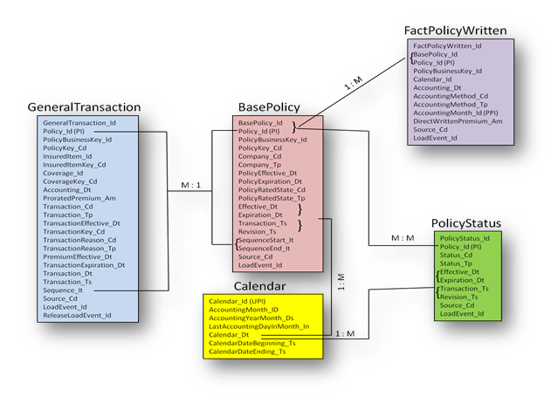
Reference: On Your Side: Nationwide’s Automobile Policy Rate Management
System – GSRM (Mark N.Folick Xavier university , Thilini Ariychandra Xavier University)

An ER diagram to represent Nationwide would include the relationships between Nationwide's sales agents and customers, customers and accounts, and what type of account each customer has (Auto insurance, home insurance, etc.).

Detailed Functional Requirements

Not applicable to this assignment.

Sub-system

Not applicable to this assignment.

Component Type

Not applicable to this assignment.

Component 1

Not applicable to this assignment.

Non-Functional Requirements

Technical Requirements

Applicable Current Standards

Standard |  | Description | Reference
Coding |  | Coding standards are specific to the development tool and define, naming conventions and the structure and formatting of programs in the new system. Coding standards include SQL standards which define techniques for data access. | Reference ITS Coding standards/Best Practices.  - JDeveloper  - Oracle Warehousing  - PL/SQL  - Java
Web/Mobile Presentation (GUI) |  | GUI standards establish the look and feel of the user interface and how components are assembled. This includes applications styles (e.g. dockable menus), application frameworks, (e.g., Microsoft MFC) and standardized GUI components (e.g., message boxes, menus etc.) | Reference ITS Web Development Standards  OR  Reference Mobile Development Best Practices
Help System |  | Help System standards define the tools and overall design standards for the application help system. This includes standards for page and field level help, how help content is defined and maintained and how help interfaces with other definitional aspects of the application (i.e. data dictionary, system and user documentation). | Reference ITS Help System Standards.
Metadata |  | Metadata standards define the methods and naming conventions used to develop the data model. | Reference ITS Metadata Standards.
Software Configuration Management (SCM) |  | SCM standards define the tool(s) and methods for managing and tracking changes to application software as it evolves through the development lifecycle. | Reference ITS Software Configuration Standards.
 | Software Quality Assurance (SQA) | SQA standards define the processes and metrics used to ensure and measure software quality. | Reference ITS Software Quality Assurance Standards.

Accessibility

Not applicable to this assignment.

Standard | Description | Reference
Accessibility for people with disabilities | New York State's Information Technology Policy on Accessibility of Web-Based Information and Applications is based on Federal Section 508 Standards, Subpart B, section 1194.22 and Subpart C, section 1194.3  It establishes minimum accessibility requirements for web-based Information and Applications developed, procured, maintained or used by state entities. | STATEWIDE:  NYS IT Policy NYS-P08-005 Accessibility of Web-Based Information and Applications  Contact the State Agency Accessibility Coordinator with questions and for guidance about the policy, the interpretation, and QA/QC activities for a particular agency.  NYS-P08-005 State Agency Accessibility Coordinators  Guide to implementing the Section 508 Standards for Electronic and Information Technology is available at US Access Board  Web Accessibility Initiative (WAI) on World Wide Web Consortium offers strategies, guidelines, and resources for designing, developing and implementing accessible Web applications. http://www.w3.org/WAI/

# | Requirements | Priority  M – Must  S – Should  C – Could  W – Won’t | Additional Information
1 | APPLICABLE CURRENT STANDARDS-Accessibility | M
2 | Exemption from APPLICABLE CURRENT STANDARDS-Accessibility (Full/Partial) | M
3 | Assistive Technology required for employees who need it | M

Encryption

# | Requirements | Priority  M – Must  S – Should  C – Could  W – Won’t | Additional Information
1 | All transactions must be encrypted | M
2 | Passwords must be encrypted | M
3 | Encryption must be at least 1024 bit | M
4 | Customer personal information must be encrypted | M | For security reasons. Only high-ups can access

Hosting

# | Requirements | Priority  M – Must  S – Should  C – Could  W – Won’t | Additional Information
1 | System operates on internal agency hardware | M
2 | Data is hosted to the central data warehouse on site in a safe location | M

Environment

Not applicable to this assignment.

Business Continuity

Any system downtime will cost Nationwide thousands in dollars. Customers will be unable to review their accounts and employees will be unable to maintain the data infrastructure. In the worst-case scenario, important data could get corrupted or lost.

In the event of an outage, UPS devices connected to servers will ensure that operations continue for 30 minutes before the servers have to be shut down.

Disaster Recovery

# | Requirements | Priority  M – Must  S – Should  C – Could  W – Won’t | Additional Information
1 | The service and system must be restored within 1 hour after an outage | M
2 | System is backed up whenever data is changed | M
3 | The location to back up the systems and data must be at an alternate safe location | M
4 | Must have a generator on site | M

Security Analysis

Not applicable to this assignment.
Standard | Description | Reference
Security Standards | Security Standards identify user types and access controls that are standard across applications. | Reference ITS- Security Standards and Guidelines.

Application Security

Security Requirements
# | Requirements | Priority  M – Must  S – Should  C – Could  W – Won’t | Additional Information
1 | Views and privileges must be created so only high-ups can see private personal information | M
2 | Must have proper security to protect all data and customer confidentiality. The system must be near inaccessible to hackers/intruders | M
3 | Data must be password-protected | M

Application Access and Decision Making Authorization

Not applicable to this assignment.

Role | Description | Permissions | Restrictions
<role1>
<role2>
<role3>
Etc.

ISO Security Model (Data Classification)

Not applicable to this assignment.

Data Integrity

# | Requirements | Priority  M – Must  S – Should  C – Could  W – Won’t | Additional Information
1 | Margin of error must be less than 0.5% | M
2 | Consistent policies between both companies | M
3 | Standardized data between both companies | M

Design Constraints

# | Constraints
1 | All databases must use Oracle SQL Server
2 | Naming conventions for table names and attributes must be followed
3 | Date datatype must be formatted into YYYY/MM/DD

Infrastructure and Application Architecture Requirements

# | Requirements | Priority  M – Must  S – Should  C – Could  W – Won’t | Additional Information
1 | Database solutions must use Oracle SQL Server | M

Non-User Interfaces

Not applicable to this assignment.

Identifier | Name of External Interface (filename or report identifier).
Source | Source of External Interface (function, system or organization)
Destination | Destination of External Interface (function, system or organization)
Type | Media of Interface (EDI, XML, tape, EFT)
Reference | Reference to supporting documentation including file descriptions and required data definitions.

Hardware Interfaces

# | Requirements | Priority  M – Must  S – Should  C – Could  W – Won’t | Additional Information
1 | Use Cisco equipment for networking | M
2 | Any two devices within the organization can connect directly to each other | M

Software Interfaces

This section describes software interfaces to other components of the software system. These may be purchased components, components reused from another application, or components being developed for subsystems outside of the scope of this project, but with which this software application must interact.

# | Requirements | Priority  M – Must  S – Should  C – Could  W – Won’t | Additional Information
1 | The DBMS must prove standard-based drivers for JDBC, ODBC, and .NET | M

Communications Interfaces

# | Requirements | Priority  M – Must  S – Should  C – Could  W – Won’t | Additional Information
1 | Employees can only connect remotely securely through a VPN | M
2 | Entire departments can receive e-mails and notifications at once | S

Legal, Copyright and Other Notices

Not applicable to this assignment.
# | Requirements | Priority  M – Must  S – Should  C – Could  W – Won’t | Additional Information

Purchased Components and Licensing Requirements

Not applicable to this assignment.
# | Requirements | Priority  M – Must  S – Should  C – Could  W – Won’t | Additional Information

Operational Requirements

System Performance

Performance Requirements

# | Requirement | Source | Additional Information
e.g. | Enterprise Dashboards must not take more than 6 seconds to load. | Contract CMS-1234
1 | All information can be constantly backed up without a noticeable impact on performance |  | Internal or external drive
2 | The system should handle any amount of transactions per second

Performance Objectives and Thresholds

# | Objective with Threshold | Source | Additional Information
e.g. | Normal response time should not be greater than 3 seconds to return each page or requested item. Threshold=6 seconds during extreme load conditions. | Contract CMS-1234 'response should be equal to or better than current system/version' | Response metrics were developed with a MO Project Leader performing the functions in v6.1 and QMU analyst using a stopwatch to record response times.
1 | It should take no more than 30 seconds to search for any item/record in the databases. Threshold = 1 minute
2 | Database loading time should take less than 30 seconds.
3 | Data must go through the processing section within 10 seconds before being stored. Threshold = 30 seconds
4 | There should be absolutely no freezes or crashes

Availability

# | Requirements | Priority  M – Must  S – Should  C – Could  W – Won’t | Additional Information
1 | The databases and servers must be available 24x7, 365 days a year. | M
2 | Databases and servers must be back in service within 1 hour of an outage. | M

System Capacity and Scalability Requirements

# | Requirements | Priority  M – Must  S – Should  C – Could  W – Won’t | Additional Information
1 | System must handle 10,000 concurrent users | M
2 | System must handle any amount of concurrent transactions | M

Usability Requirements

# | Requirements | Priority  M – Must  S – Should  C – Could  W – Won’t | Additional Information
1 | 1 month of training will be enough for an employee to learn the system in and out | M
2 | Interface elements should be easy to use and understand to both employees and customers | S
3 | The interface should operate with consistency | S
4 | The system could be customizable to meet customers' needs and preferences | C
5 | The screen layout and color should be appealing to user | S
6 | All data must be easy for the user to access, understand, and save. | M

Flexibility Requirements

Not applicable to this assignment.

# | Requirements | Priority  M – Must  S – Should  C – Could  W – Won’t | Additional Information

Robustness Requirements

Not applicable to this assignment.

# | Requirements | Priority  M – Must  S – Should  C – Could  W – Won’t | Additional Information

Audit and Controls

# | Requirements | Priority  M – Must  S – Should  C – Could  W – Won’t | Additional Information
1 | Event log and change management log must be kept. | M

Software Quality Assurance (SQA)

Not applicable to this assignment.

# | Requirements | Priority  M – Must  S – Should  C – Could  W – Won’t | Additional Information

System Administration

# | Requirements | Priority  M – Must  S – Should  C – Could  W – Won’t | Additional Information
1 | Employees report problems to supervisors with the press of a button | M
2 | Supervisors handles concerns, questions, and small issues. Larger issues are escalated to management | M
3 | Management fixes major problems | M

Backup and Recovery

# | Requirements | Priority  M – Must  S – Should  C – Could  W – Won’t | Additional Information
1 | Backups are created or saved for every data change | M
2 | Recoveries are performed within 1 hour after a significate loss or corruption of data | M

Archiving and Retention Requirements

# | Requirements | Priority  M – Must  S – Should  C – Could  W – Won’t | Additional Information
1 | Store claims and transaction data within short-term database from three-five years. Afterward, the data is transferred to tapes. | M
2 | Summarized data is stored in the long-term database for 25 years | M

Transitional Requirements

Data Conversion

# | Requirements | Priority  M – Must  S – Should  C – Could  W – Won’t | Additional Information
1 | A validation check is required after a data conversion. | M
2 | All data will be converted and migrated to the new system. | M

Training Requirements

# | Requirements | Priority  M – Must  S – Should  C – Could  W – Won’t | Additional Information
1 | New employees undergo a month of training for managing data systems. | M
2 | Employees must complete a final evaluation at the end of the data management training. | M
3 | Help desk personnel are trained for one week | M

Roles of Customers/Consumers of the System

As customers come in and purchase insurance, their data along with their insurance selected will need to be stored. This data can be used to determine the most popular insurance types, demographics, and other factors that can help the business better connect with its customers.

Support Requirements

Support Type
Type of support required; Help Desk Support, Network Support, Application Support, Database Support, Security, Training or Administrative Support. Each system may require multiple Support Types.
Service  Level Definition | Defines expectations related to system performance and availability and the related support needs in a way that can be measured. Support needs include requirements for help desk problem resolution turnaround, support coverage/schedule, defect resolution turnaround, systems availability, security support and other service needs as defined by the customer.  It is not expected that a “Service Level Agreement” will be developed for each application. However, an assessment of the operational support needs of the business application should be developed to determine if those needs fall within the parameters of ITS’ existing support levels.  Service level is generally limited to online remote support (for example, remote desktop support) unless major issues (should be included in the contract).
Role | The roles expected to be performed by support individuals. Role definitions are available in the Roles and Responsibility appendix. For example: Application Support may require a Business Analyst, Developer and Tester. Database Support may include Data Architect and DBA.  Application support is performed by an experienced application developer. Database support is performed by DBA. Network support by network technician. Help desk and training support by general support team.
Estimated HRS/WK | Estimated hours per week of support for roles defined.  2 hours per week of support (should be included in the contract).

Documentation

# | Requirements | Priority  M – Must  S – Should  C – Could  W – Won’t | Additional Information
1 | Employees working with the data system must keep their own documentation logs | M
2 | User manuals and other documentation must be easily accessible at anytime | M

Help

# | Requirements | Priority  M – Must  S – Should  C – Could  W – Won’t | Additional Information
1 | Data system comes with built-in help button for each feature. Each button links to an online help document for the user | S
2 | System also comes with link to a call centre for more help if needed | S | Some find it easier to deal with a person over the phone rather than searching for help.

Deployment

# | Requirements | Priority  M – Must  S – Should  C – Could  W – Won’t | Additional Information
1 | Phased Rollout will help employees get used to new features one piece at a time | M

Release Validation

# | Requirements | Priority  M – Must  S – Should  C – Could  W – Won’t | Additional Information
1 | Must have a presentation showing the results and provide a brochure as a hard copy of the presentation. | M

